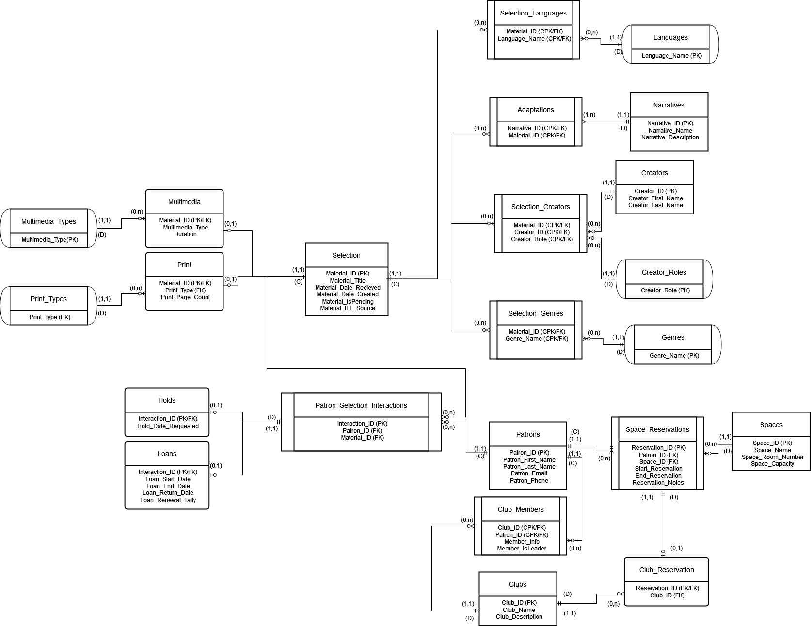

**Patrons - Patron_Selection_Interaction - Selection**

The relationship of Patron_Selection_Interaction (between Patrons and materials from the Selection) establishes which patrons have had interactions with which materials, to be clarified in subset tables.

**Holds - Patron_Selection_Interaction**

The relationship of Holds and Patron_Selection_Interactions establishes which interaction is a hold.

**Loans - Patron_Selection_Interaction**

The relationship of Loans and Patron_Selection_Interactions establishes which interaction is a loan.

**Patrons - Club_Members - Clubs**

The relationship of Club_Members (between Patrons and Clubs) establishes which patrons are in which club at the library.

**Patrons - Space_Reservations - Spaces**

The relationship of Space_Reservations (between Patrons and Spaces) establishes which patrons have reserved which rooms, and when, in the library.

**Space_Reservations - Club_Reservations**

The relationship of Space_Reservations and Club_Reservations identifies that a reservation is for a club activity, as well as which club reserved it.

**Selection - Adaptations - Narratives**

The relationship between Narratives and Selection (Adaptations) establishes which material (in Selection) is adapted from a similar Narrative as another in the selection. This includes specific narratives such as to highlight translations, as well as general inspirations/connections such as a retelling.

**Selection - Selection_Creators - Creators, Creator_Roles**

The relationship of Selection_Creators (between Selection, Creators, and Creators_Roles) establishes which materials in the Selection have been created by which Creators and in what capacity or Role (e.g. authorial, editorial, directorial, etc.)

**Selection - Selection_Genres - Genres**

The relationship of Selection_Genres (between Selection and Genres) establishes materials in Selection are categorized under which Genres.

**Selection - Selection-Languages - Languages**

The relationship of Selection_Languages (between Selection and Languages) establishes that materials in Selection are written in or have which Languages within them (or have content in that language).

**Selection - Multimedia**

The relationship between Selection and Multimedia establishes that a material in the selection is a Multimedia work (i.e. not a print material).

**Selection - Print**

The relationship between Selection and Print establishes that a material in the selection is a Print work.

**Print - Print_Types**

The relationship between Print and Print_Types establishes which print type in particular a print material is (e.g. book, periodical)

**Multimedia - Multimedia_Types**

The relationship between Multimedia and Multimedia_Types establishes which multimedia type in particular a multimedia material is (e.g. film, audio book)